ASSESSMENT TOOL 3 – EXPLORATORY DATA ANALYSIS
Course: Fundamentals of Data Science
Course Code: DSA04
Course Outcome: CO5
AT3 – EXPLORATORY DATA ANALYSIS

Submitted by
E.C. Jithendra Kumar Reddy
192472180

EDUCATION ANALYTICS DATASET
1.1 Dataset Description
The Education Analytics dataset contains 20 student records and 5 features. It is used to study the relationship between attendance, study hours, internal marks and final result.
Feature | Data Type | Role
Student_ID | object | Unique identifier
Attendance | int64 | Numerical variable (%)
Study_Hours | int64 | Numerical variable (hours/day)
Internal_Marks | int64 | Numerical variable (/50)
Result | object | Categorical target: Pass / Fail
1.2 Purpose & Significance
A college wants to analyze student performance based on attendance, study hours and internal marks. The purpose of the analysis is to identify the factors associated with student results and support early academic intervention for students who may be at risk of failing.
1.3 Data Cleaning & Preprocessing
- Missing values: 0 missing values were found in the dataset, so no imputation was required.
- Duplicate records: 0 duplicate rows were found.
- Inconsistency check: Result values were checked and only the labels Pass and Fail were present.
- Outlier check: The IQR method with a 1.5 × IQR limit was applied to the numerical variables. No outliers were detected.

1.4 Descriptive Statistics
Feature | Mean | Median | Minimum | Maximum | Std Dev
Attendance | 70.15 | 70.00 | 45 | 95 | 15.94
Study Hours | 3.35 | 3.00 | 1 | 6 | 1.42
Internal Marks | 32.95 | 33.50 | 18 | 48 | 9.09
1.5 Categorical Variable Analysis
Variable | Category | Count | Percentage
Result | Pass | 11 | 55%
Result | Fail | 9 | 45%
1.6 Data Visualizations
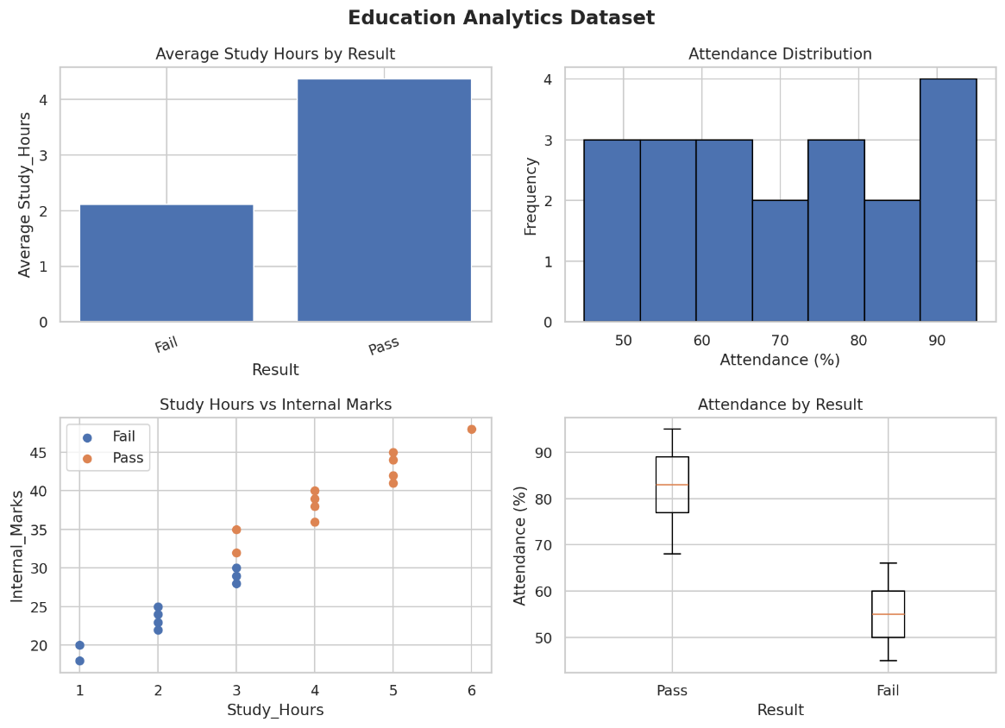.

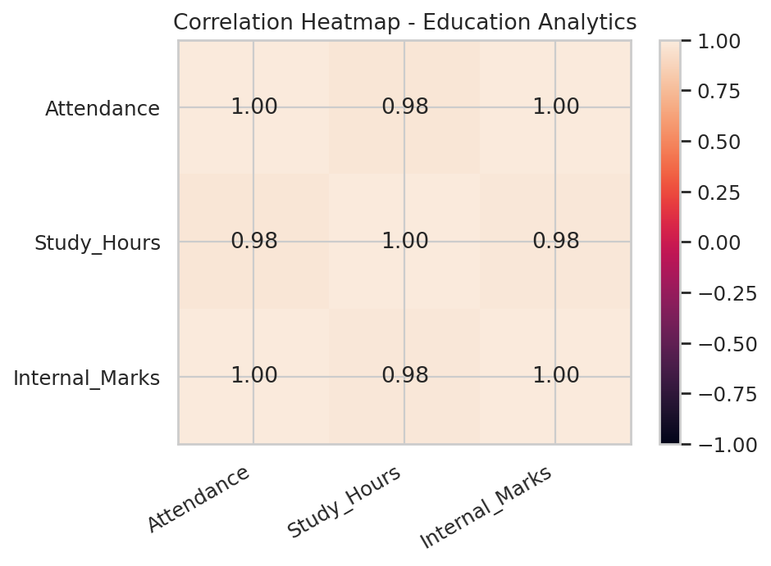

1.7 Trends, Distributions & Relationships
The analysis shows a strong positive relationship between attendance, study hours and internal marks. Students who spend more time studying generally obtain higher internal marks. Attendance also increases with better academic performance. The correlation between attendance and internal marks is very strong, showing that these variables move together in this dataset.
1.8 Key Findings & Insights
- Passing students generally have higher attendance and study hours than failing students.
- Internal marks increase as study hours increase.
- Students with lower attendance are more frequently associated with Fail results.
- Attendance, study hours and internal marks have positive relationships with one another.
- The dataset contains no missing values, duplicate records or detected IQR outliers.
1.9 Decision-Making Impact / Conclusion
The analysis indicates that attendance, study hours and internal marks are important factors associated with student results. Academic advisors can use lower attendance and low internal marks as early warning indicators and provide additional mentoring or academic support to students who need it.
2. HEALTHCARE ANALYTICS DATASET
2.1 Dataset Description
The Healthcare Analytics dataset contains 20 patient records and 6 features. It is used to analyze the relationship between age, blood sugar, blood pressure, BMI and disease status.
Feature | Data Type | Role
Patient_ID | object | Unique identifier
Age | int64 | Numerical variable (years)
Sugar_Level | int64 | Numerical variable (mg/dL)
BP | int64 | Numerical variable (mmHg)
BMI | int64 | Numerical variable
Disease_Status | object | Categorical target: Yes / No
2.2 Purpose & Significance
A hospital wants to analyze patient health risk using age, blood sugar, blood pressure and BMI. The purpose is to identify important health patterns that can help prioritize patients for further screening.
2.3 Data Cleaning & Preprocessing
- Missing values: 0 missing values were found.
- Duplicate records: 0 duplicate rows were found.
- Inconsistency check: Disease_Status contained only Yes and No with consistent formatting.
- Outlier check: The IQR method was applied to Age, Sugar_Level, BP and BMI. No outliers were detected.
2.4 Descriptive Statistics
Feature | Mean | Median | Minimum | Maximum | Std Dev
Age | 43.20 | 43.50 | 27 | 62 | 11.32
Sugar Level | 138.65 | 137.50 | 88 | 210 | 40.33
BP | 129.75 | 129.00 | 108 | 155 | 14.52
BMI | 27.30 | 27.50 | 21 | 35 | 4.26
2.5 Categorical Variable Analysis
Variable | Category | Count | Percentage
Disease_Status | Yes | 10 | 50%
Disease_Status | No | 10 | 50%

2.6 Data Visualizations
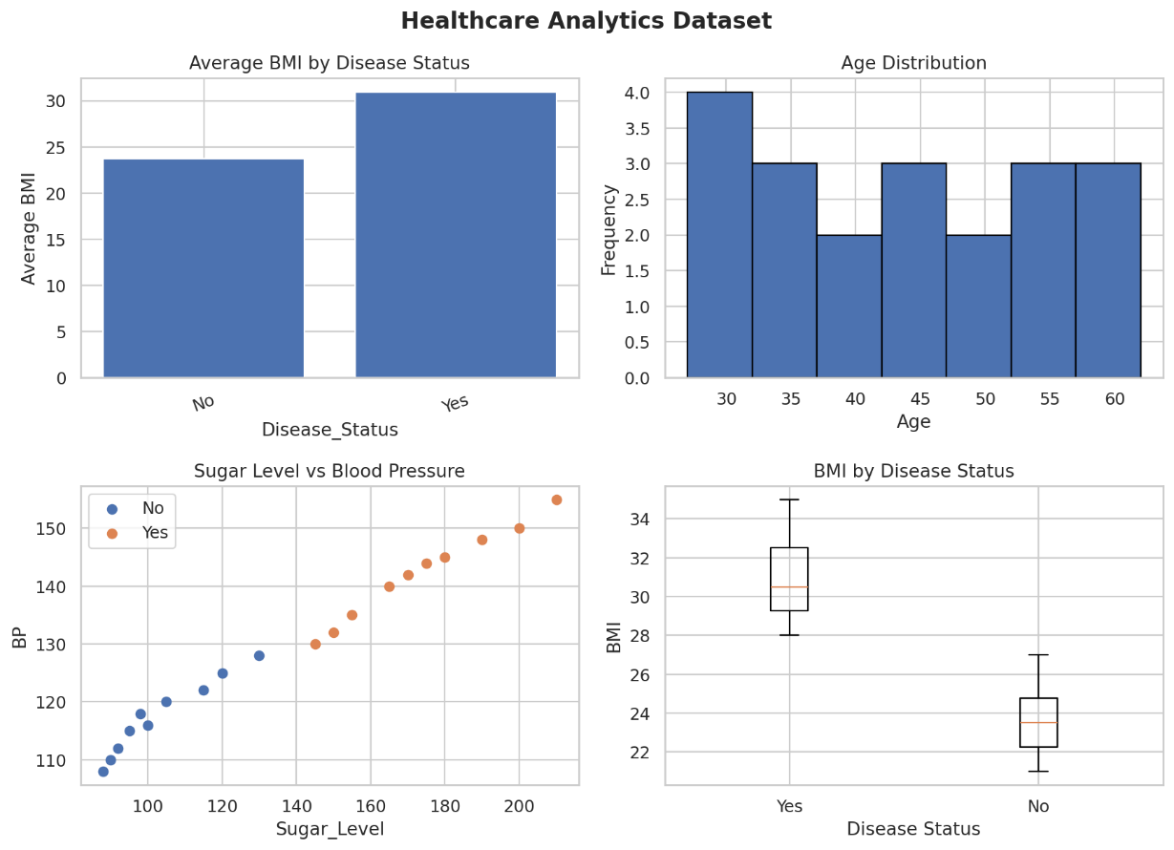
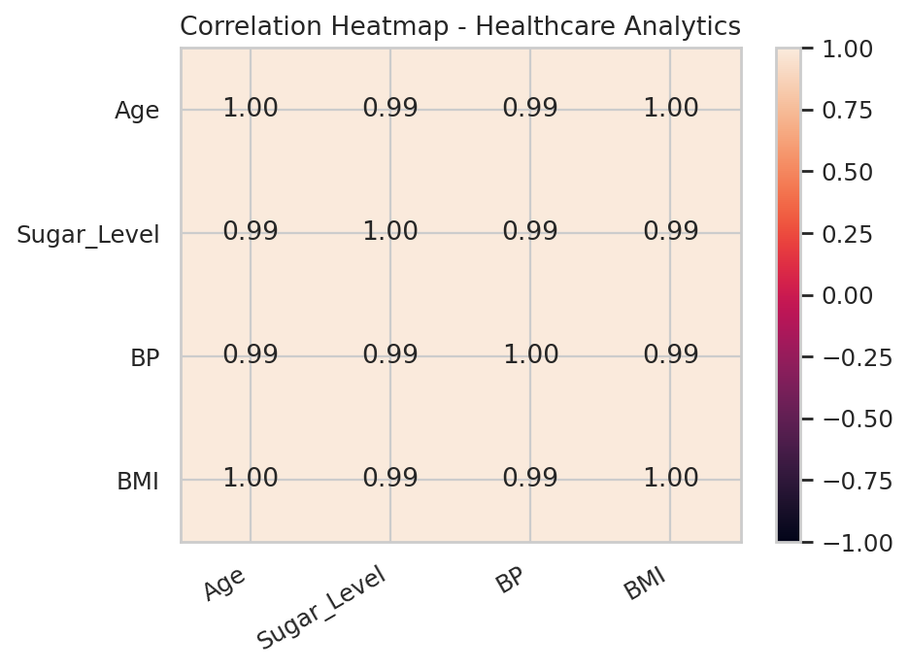

2.7 Trends, Distributions & Relationships
Disease-positive patients generally have higher sugar levels, blood pressure and BMI than disease-negative patients. The scatter plot shows that sugar level and blood pressure increase together. The box plot also shows a clear difference in BMI between the two disease-status groups.
2.8 Key Findings & Insights
- Disease-positive patients generally have higher sugar levels than disease-negative patients.
- Blood pressure is higher among disease-positive patients.
- BMI provides a clear visual difference between the two groups.
- The dataset is balanced with 10 Yes and 10 No records.
- No missing values, duplicate records or IQR outliers were detected.

2.9 Decision-Making Impact / Conclusion
The analysis indicates that BMI, blood sugar, blood pressure and age are associated with disease status in this dataset. These variables can help hospitals prioritize patients for additional screening. However, this small dataset should not be used as a clinical diagnostic rule.
3. RETAIL SALES DATASET
3.1 Dataset Description
The Retail Sales dataset contains 20 product records and 6 features. It is used to study product categories, pricing, quantity sold, discounts and revenue.
Feature | Data Type | Role
Product_ID | object | Unique identifier
Category | object | Categorical variable
Price | int64 | Numerical variable
Quantity_Sold | int64 | Numerical variable
Discount | int64 | Numerical variable (%)
Revenue | int64 | Numerical target
3.2 Purpose & Significance
A supermarket wants to analyze product sales to identify high-selling categories and revenue patterns. The analysis can support pricing, stocking and promotional decisions.

3.3 Data Cleaning & Preprocessing
- Missing values: 0 missing values were found.
- Duplicate records: 0 duplicate rows were found.
- Inconsistency check: Category values were checked and the five categories were consistently recorded.
- Outlier check: The IQR method was applied to Price, Quantity_Sold, Discount and Revenue. No outliers were detected.
3.4 Descriptive Statistics
Feature | Mean | Median | Minimum | Maximum | Std Dev
Price | 54.00 | 50.00 | 20 | 100 | 22.80
Quantity Sold | 24.00 | 21.00 | 10 | 45 | 9.67
Discount | 4.00 | 4.00 | 2 | 7 | 1.56
Revenue | 1114.00 | 1050.00 | 810 | 1540 | 221.42
3.5 Categorical Variable Analysis
Variable | Category | Count | Percentage
Category | Grocery | 4 | 20%
Category | Snacks | 4 | 20%
Category | Dairy | 4 | 20%
Category | Fruits | 4 | 20%
Category | Vegetables | 4 | 20%
3.6 Data Visualizations
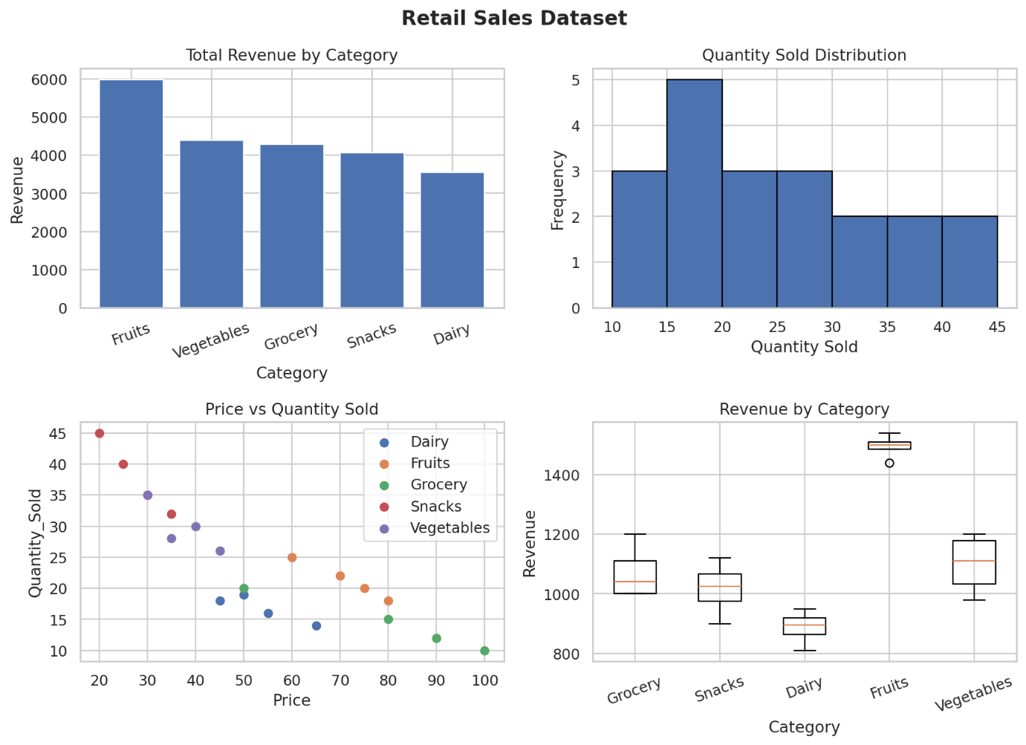
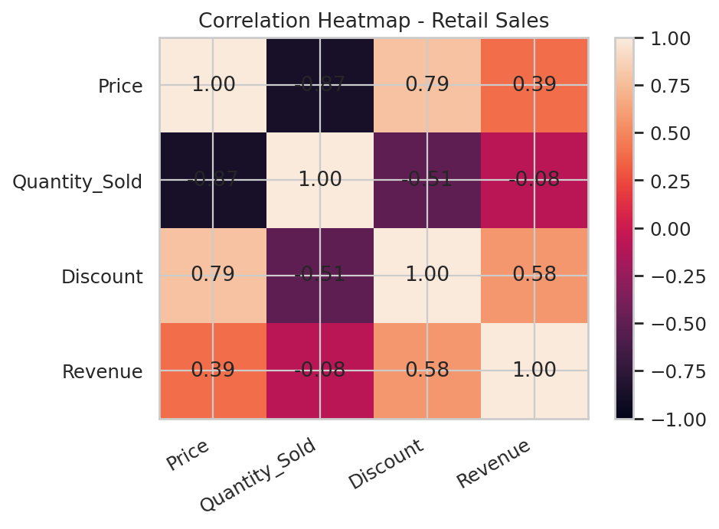

3.7 Trends, Distributions & Relationships
The analysis shows a strong negative relationship between price and quantity sold. In general, lower-priced products sell in larger quantities. Fruits generate the highest revenue among the categories, mainly because their selling prices are relatively high.
3.8 Key Findings & Insights
- Fruits generate the highest total revenue among the product categories.
- Price and quantity sold have a strong negative relationship.
- Snacks achieve high sales volume because of their lower prices.
- Revenue varies considerably between product categories.
- No missing values, duplicate records or IQR outliers were detected.
3.9 Decision-Making Impact / Conclusion
The analysis shows that both price and quantity sold influence revenue. The supermarket can prioritize Fruits and other high-revenue categories for stocking while using discounts carefully to increase sales volume without unnecessarily reducing margins.
4. BANKING LOAN APPROVAL DATASET
4.1 Dataset Description
The Banking Loan Approval dataset contains 20 customer records and 6 features. It is used to analyze loan approval patterns based on income, credit score, loan amount and employment type.
Feature | Data Type | Role
Customer_ID | object | Unique identifier
Income | int64 | Numerical variable
Credit_Score | int64 | Numerical variable
Loan_Amount | int64 | Numerical variable
Employment_Type | object | Categorical variable
Loan_Status | object | Categorical target: Approved / Rejected
4.2 Purpose & Significance
A bank wants to understand the factors associated with loan approval decisions. The analysis can help identify patterns related to credit score, income, loan amount and employment type.
4.3 Data Cleaning & Preprocessing
- Missing values: 0 missing values were found.
- Duplicate records: 0 duplicate rows were found.
- Inconsistency check: Employment_Type and Loan_Status values were consistently recorded.
- Outlier check: The IQR method was applied to Income, Credit_Score and Loan_Amount. No outliers were detected.
4.4 Descriptive Statistics
Feature | Mean | Median | Minimum | Maximum | Std Dev
Income | 43000.00 | 34500.00 | 22000 | 75000 | 17923.82
Credit Score | 664.00 | 665.00 | 555 | 790 | 85.53
Loan Amount | 223250.00 | 195000.00 | 120000 | 400000 | 83733.21
4.5 Categorical Variable Analysis
Variable | Category | Count | Percentage
Employment_Type | Salaried | 10 | 50%
Employment_Type | Self-employed | 6 | 30%
Employment_Type | Unemployed | 4 | 20%
Loan_Status | Approved | 10 | 50%
Loan_Status | Rejected | 10 | 50%
4.6 Data Visualizations
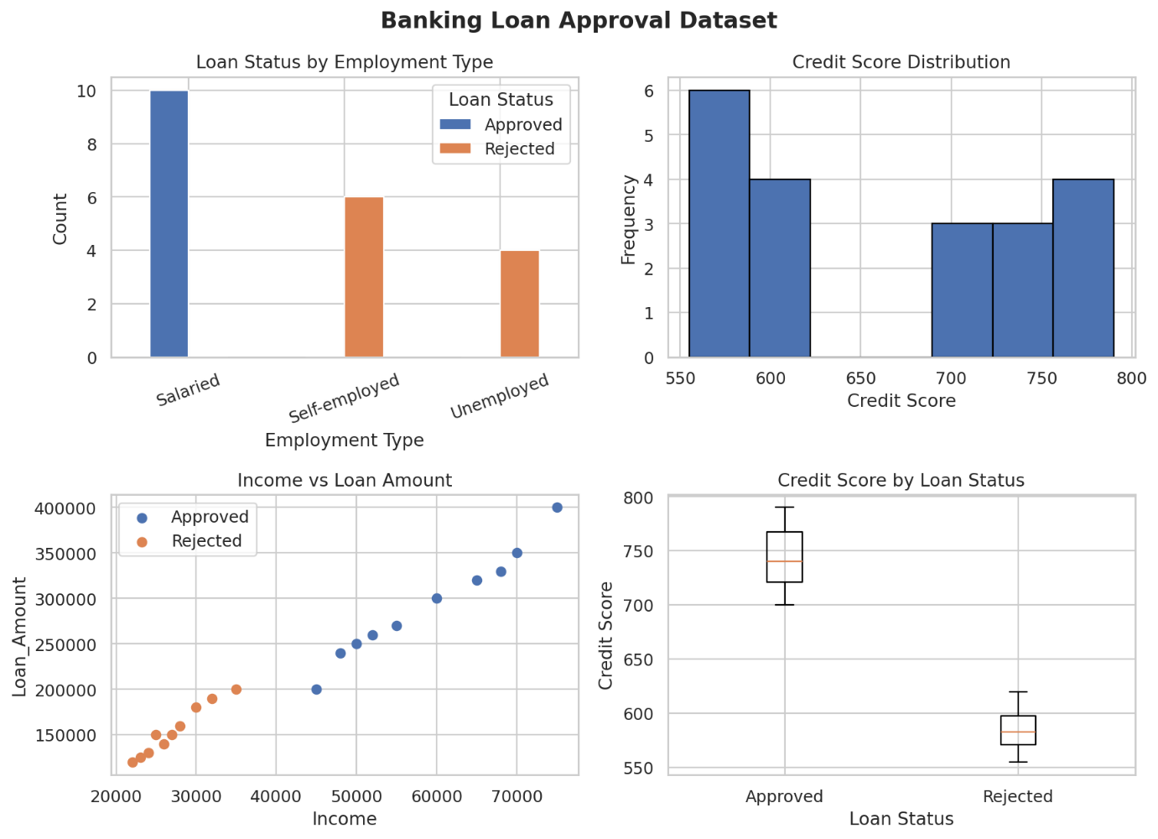
4.7 Trends, Distributions & Relationships
Approved applicants have substantially higher credit scores than rejected applicants. Income and loan amount have a strong positive relationship, showing that customers with higher income generally request larger loans. Employment type also shows a strong association with loan status in this particular dataset.
4.8 Key Findings & Insights
- Approved applicants have considerably higher credit scores than rejected applicants.
- The approved and rejected credit-score groups are clearly separated in this sample.
- Income and loan amount have a very strong positive relationship.
- All Salaried applicants in this dataset are approved, while all Unemployed applicants are rejected.
- No missing values, duplicate records or IQR outliers were detected.
4.9 Decision-Making Impact / Conclusion
Credit score, income and employment type show strong associations with loan approval in this dataset. These patterns can support preliminary application screening, but actual banking decisions should use larger and more representative datasets to avoid unfair or unreliable conclusions.
5. AGRICULTURE CROP YIELD DATASET
5.1 Dataset Description
The Agriculture Crop Yield dataset contains 20 farm records and 6 features. It is used to analyze the effect of rainfall, temperature, fertilizer usage and soil type on crop yield.
Feature | Data Type | Role
Farm_ID | object | Unique identifier
Rainfall_mm | int64 | Numerical variable
Temperature | int64 | Numerical variable (°C)
Fertilizer_kg | int64 | Numerical variable
Soil_Type | object | Categorical variable
Crop_Yield_kg | int64 | Numerical target
5.2 Purpose & Significance
An agricultural department wants to identify the factors influencing crop production. The analysis focuses on rainfall, temperature, fertilizer usage and soil type to support better agricultural planning.
5.3 Data Cleaning & Preprocessing
- Missing values: 0 missing values were found.
- Duplicate records: 0 duplicate rows were found.
- Inconsistency check: Soil_Type values were checked and only Loamy, Sandy and Clay were present.
- Outlier check: The IQR method was applied to Rainfall_mm, Temperature, Fertilizer_kg and Crop_Yield_kg. No outliers were detected.
5.4 Descriptive Statistics
Feature | Mean | Median | Minimum | Maximum | Std Dev
Rainfall (mm) | 743.00 | 750.00 | 500 | 960 | 144.34
Temperature | 29.55 | 29.00 | 25 | 34 | 2.76
Fertilizer (kg) | 54.75 | 55.00 | 40 | 75 | 10.51
Crop Yield (kg) | 2820.00 | 2975.00 | 1800 | 3900 | 681.41
5.5 Categorical Variable Analysis
Variable | Category | Count | Percentage
Soil_Type | Loamy | 7 | 35%
Soil_Type | Sandy | 7 | 35%
Soil_Type | Clay | 6 | 30%
5.6 Data Visualizations
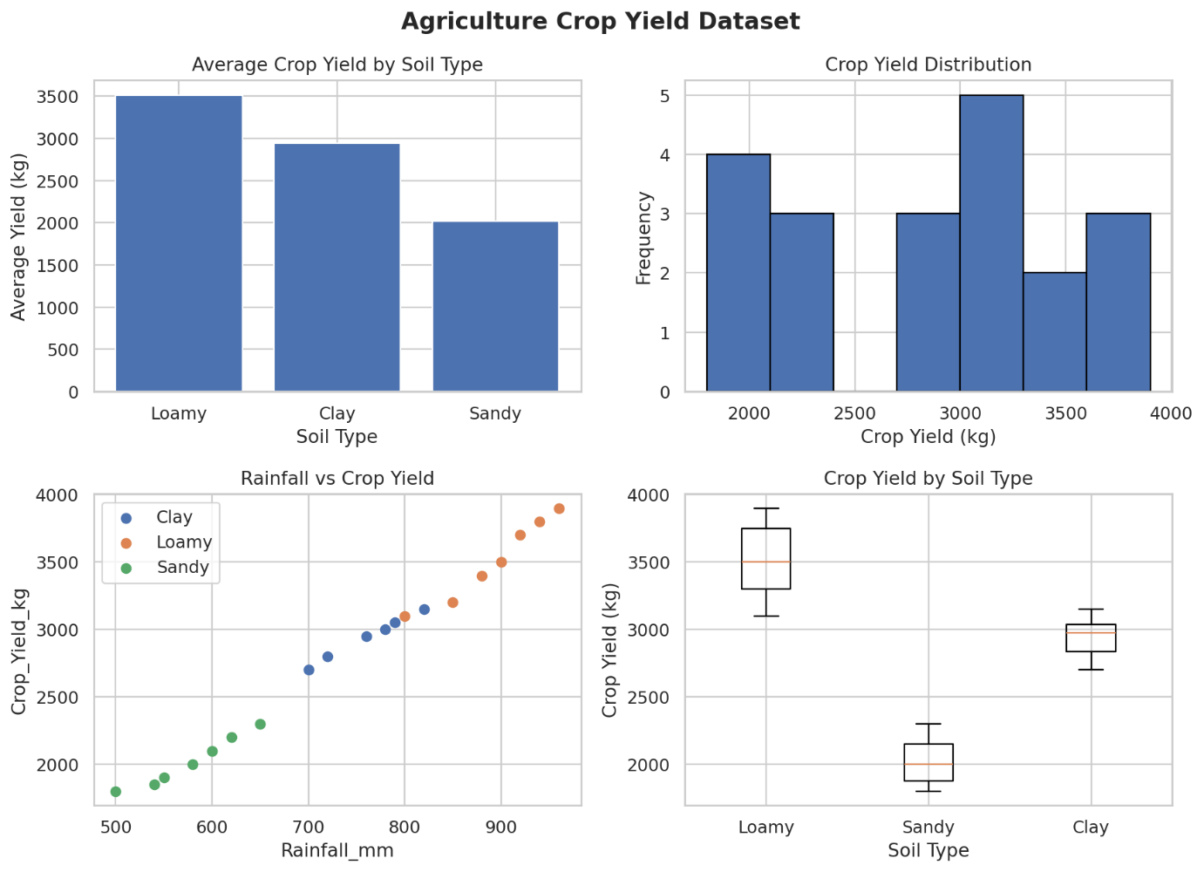
5.7 Trends, Distributions & Relationships
The analysis shows a very strong positive relationship between rainfall and crop yield. Temperature has a strong negative relationship with crop yield. Farms with higher rainfall generally produce higher crop yields. Loamy soil has the highest average yield, while Sandy soil has the lowest average yield in this dataset.
5.8 Key Findings & Insights
- Rainfall has a very strong positive relationship with crop yield.
- Temperature has a strong negative relationship with crop yield.
- Loamy soil produces the highest average crop yield.
- Fertilizer usage is positively associated with crop yield in this sample.
- No missing values, duplicate records or IQR outliers were detected.
5.9 Decision-Making Impact / Conclusion
The analysis indicates that rainfall, temperature, fertilizer usage and soil type are important factors associated with crop yield. Agricultural planning can use these patterns to improve irrigation planning, fertilizer recommendations and soil-specific crop management.

OVERALL CONCLUSION
The Exploratory Data Analysis of the five datasets demonstrates how data cleaning, descriptive statistics, categorical analysis and visualization can be used to identify meaningful patterns.
The Education dataset shows the importance of attendance and study hours in student performance. The Healthcare dataset shows differences in health-related measurements between disease-status groups. The Retail dataset demonstrates the relationship between price, quantity sold and revenue. The Banking dataset shows strong associations between credit score, income, employment type and loan approval. The Agriculture dataset demonstrates strong relationships between rainfall, temperature, fertilizer usage, soil type and crop yield.
Overall, EDA helps convert raw data into useful information that can support better decision-making in education, healthcare, retail, banking and agriculture.

